

BETZ IS AN ACCREDITED INTERNATIONAL AGENCY
For
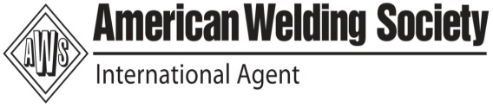
AMERICAN WELDING SOCIETY , U.S.A
Conduct Seminar and Certification programs for AWS in India and Overseas
AWS- CWI Calendar for the Year -2012
AWS - CWI CALENDAR FOR THE YEAR 2012
S.No | Month | Seminar Dates | Seminar -City | Study  Holiday | Date of Exam | Exam-City
1 | January | 22-29 | Chennai | 30 | 31st January | Chennai
2 | February | 19-26 | Chennai | 27 | 28th February | Coimbatore
3 | March | 22-29 | Chennai | 30 | 31st March | Chennai
4 | April | 22 - 28 | Chennai | 29 | 30th April | Chennai
5 | May | 20-27 | Chennai | 28 | 29th May | Chennai
6 | June | 21-28 | Chennai | 29 | 30th June | Chennai
7 | July | 22-29 | Chennai | 30 | 31st July | Coimbatore
8 | August | 19-26 | Chennai | 27 | 28th August | Chennai
9 | September | 20-27 | Chennai | 28 | 29th September | Chennai
10 | October | 21-28 | Chennai | 29 | 30th October | Chennai
11 | November | 18-25 | Chennai | 26 | 27th November | Trichy
12 | December | 20-27 | Chennai | 28 | 29th December | Coimbatore
BETZ EDUCATIONAL & RESEARCH DIVISION
21- Dharakeshwari 1st Street , Sembakkam, Tambaram
(Tambaram to Velacherry main road )
Chennai – 600 073 , Phone # 044-22780291/Mobile # 9551665682/83
E-mail : rg_ganesan@yahoo.com/betzzone@vsnl.net
Web : www.welding-certification.com

